B.AKSHITHA --2520090014

DDL, DML, DCL & TCL
SECTION 1 : DDL(DATA DEFINITION LANGUAGE)

QUESTION 1:- CREATE TABLE
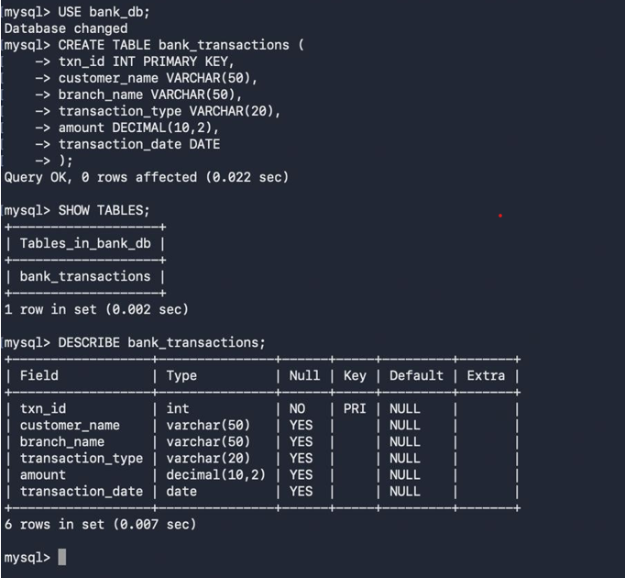

QUESTION 2:- ALTER TABLE AND COLUMN
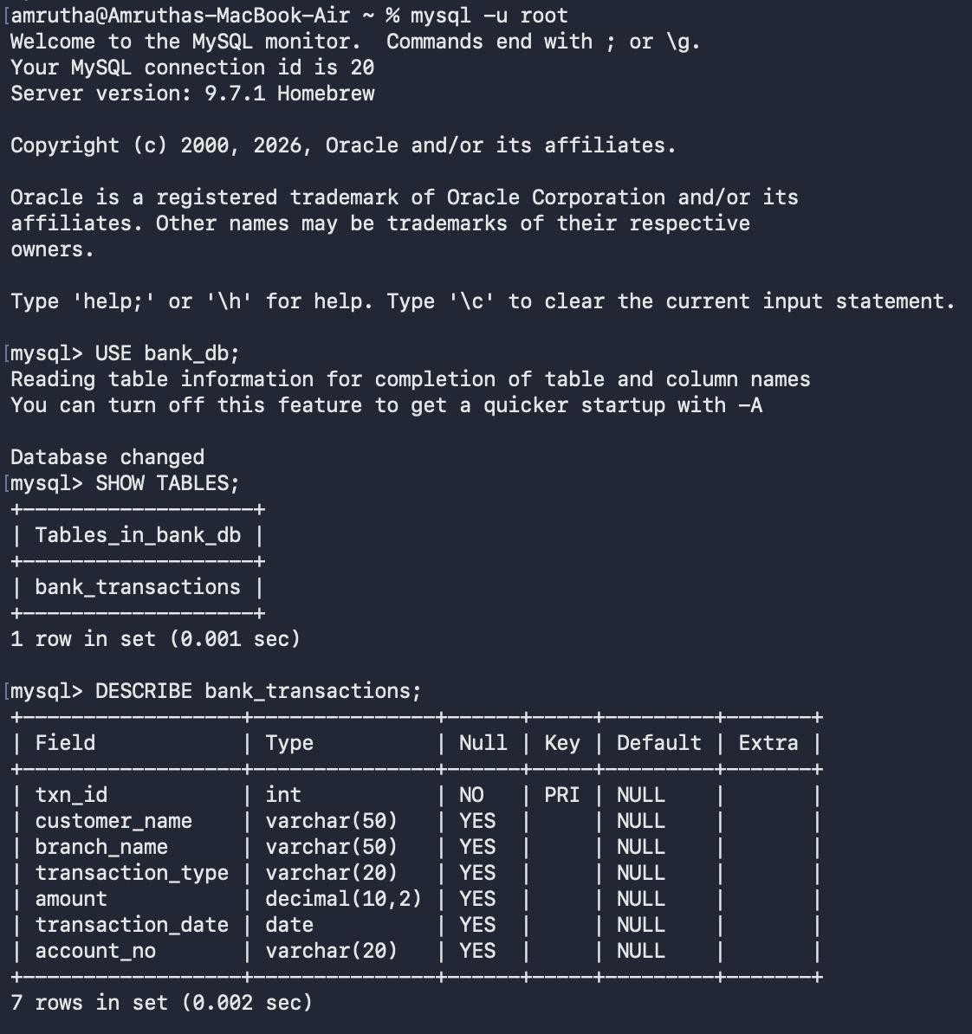

QUESTION 3:- ALTER TABLE MODIFY COLUMN
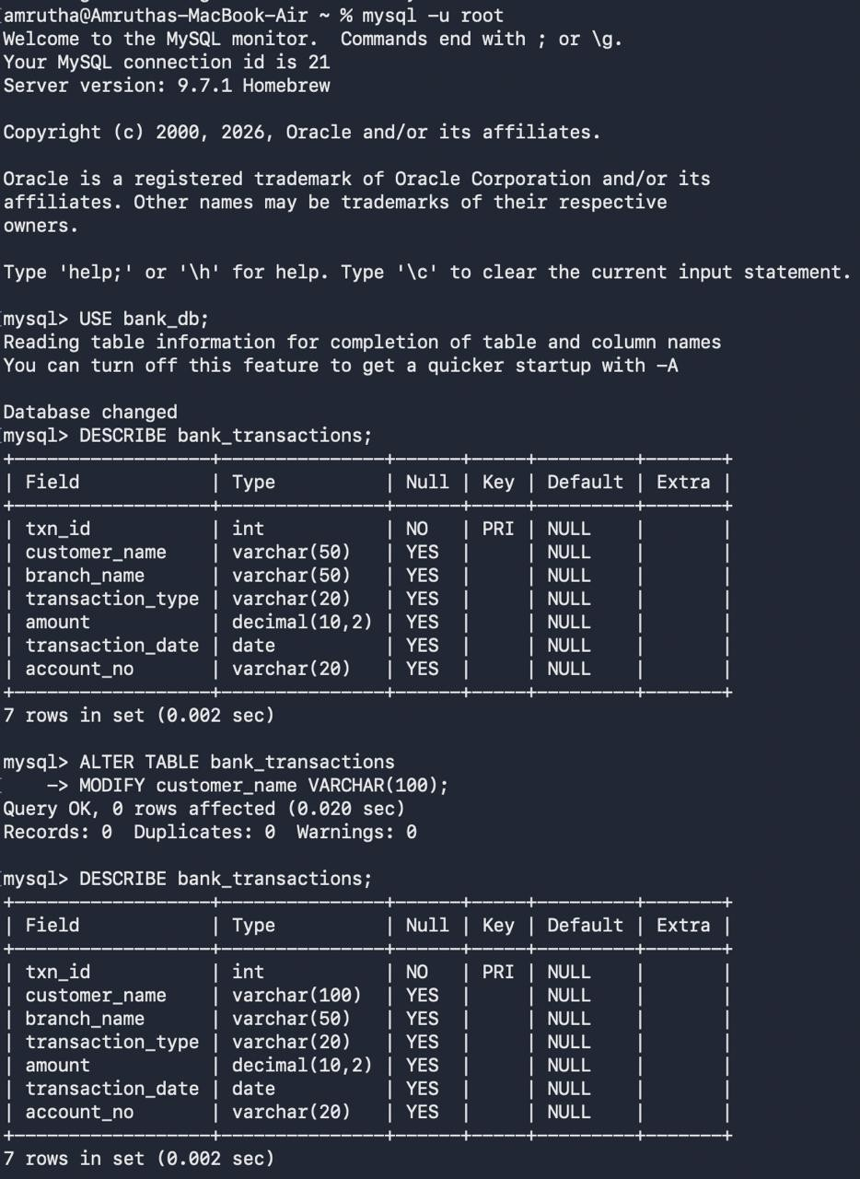

QUESTION 4:- RENAME TABLE
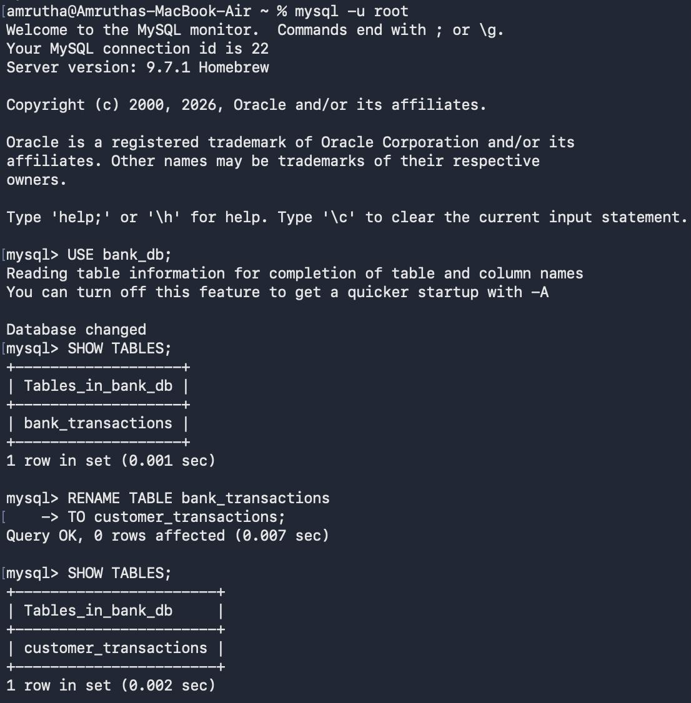

QUESTION 5:- TRUNCATE TABLE
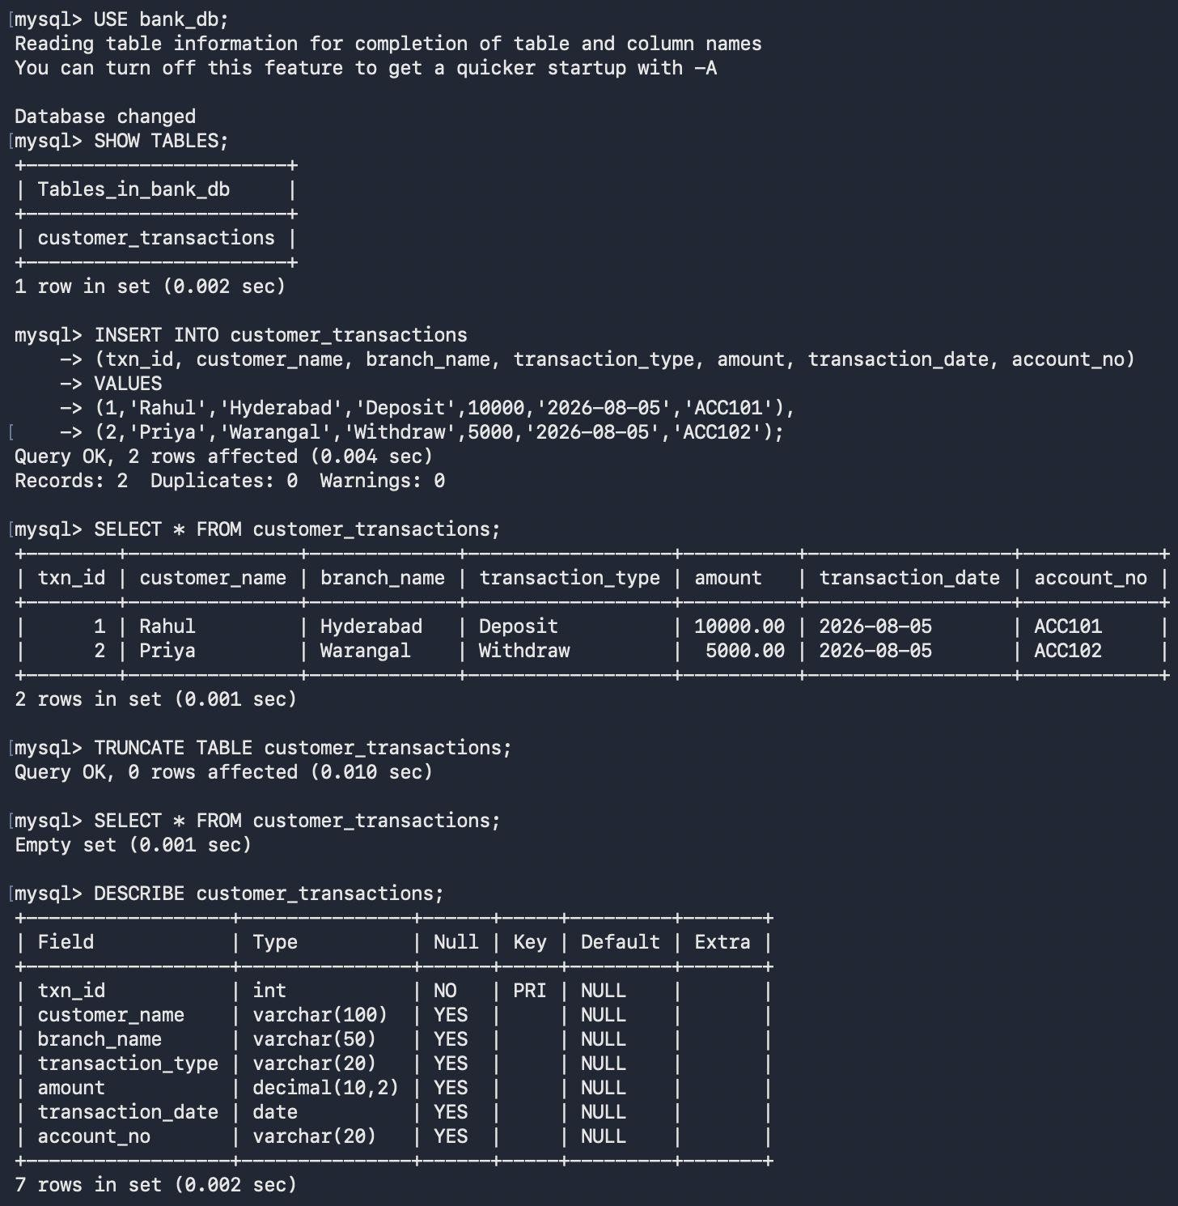

QUESTION 6:- DROP TABLE
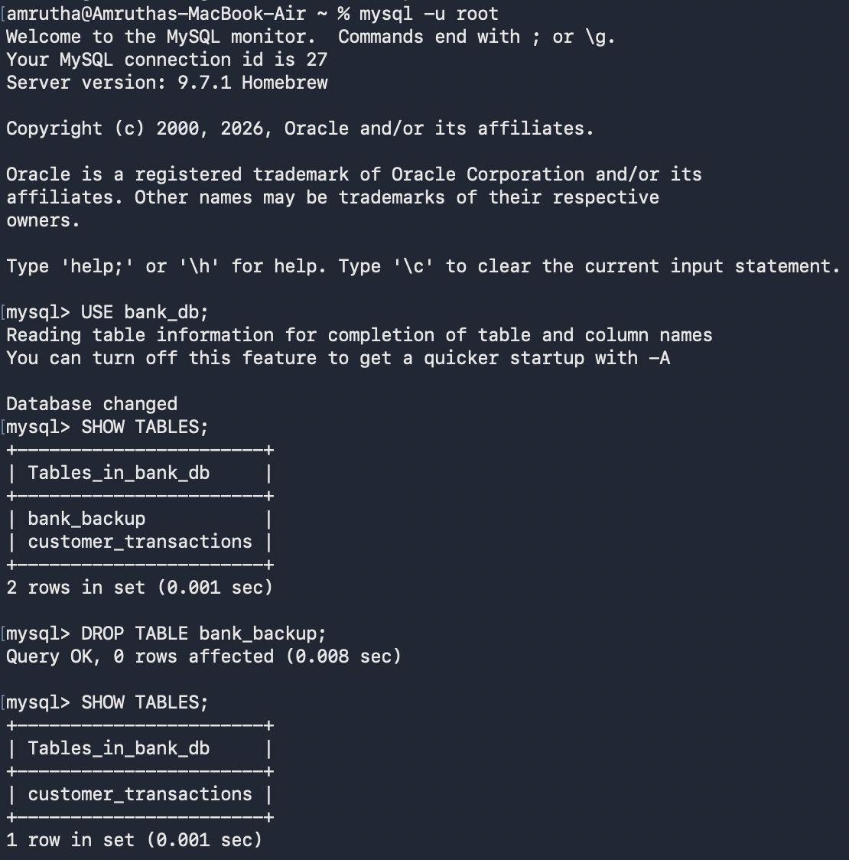
SECTION 2 : DML(DATA MANIPULATION LANGUAGE)
QUESTION 7:- INSERT SAMPLE DATA
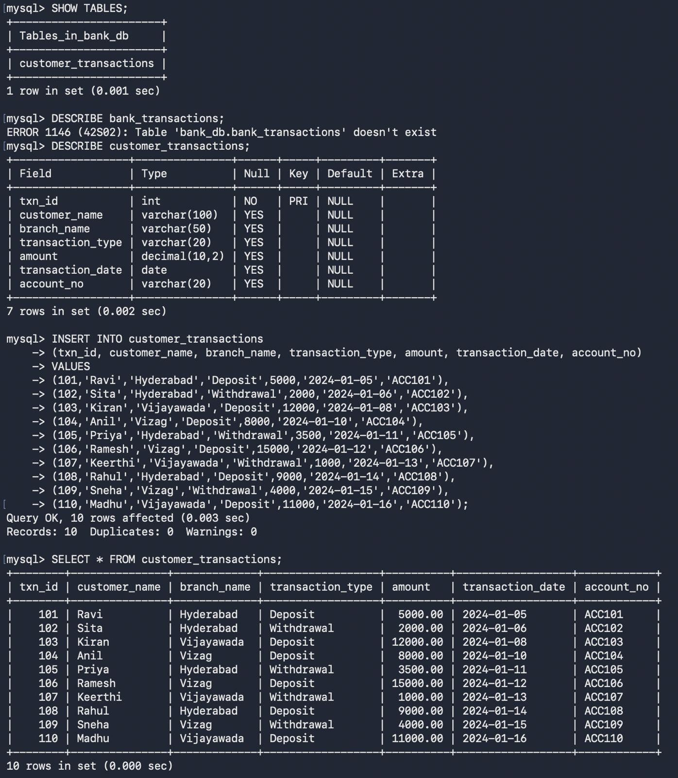

QUESTION 8:- UPDATE
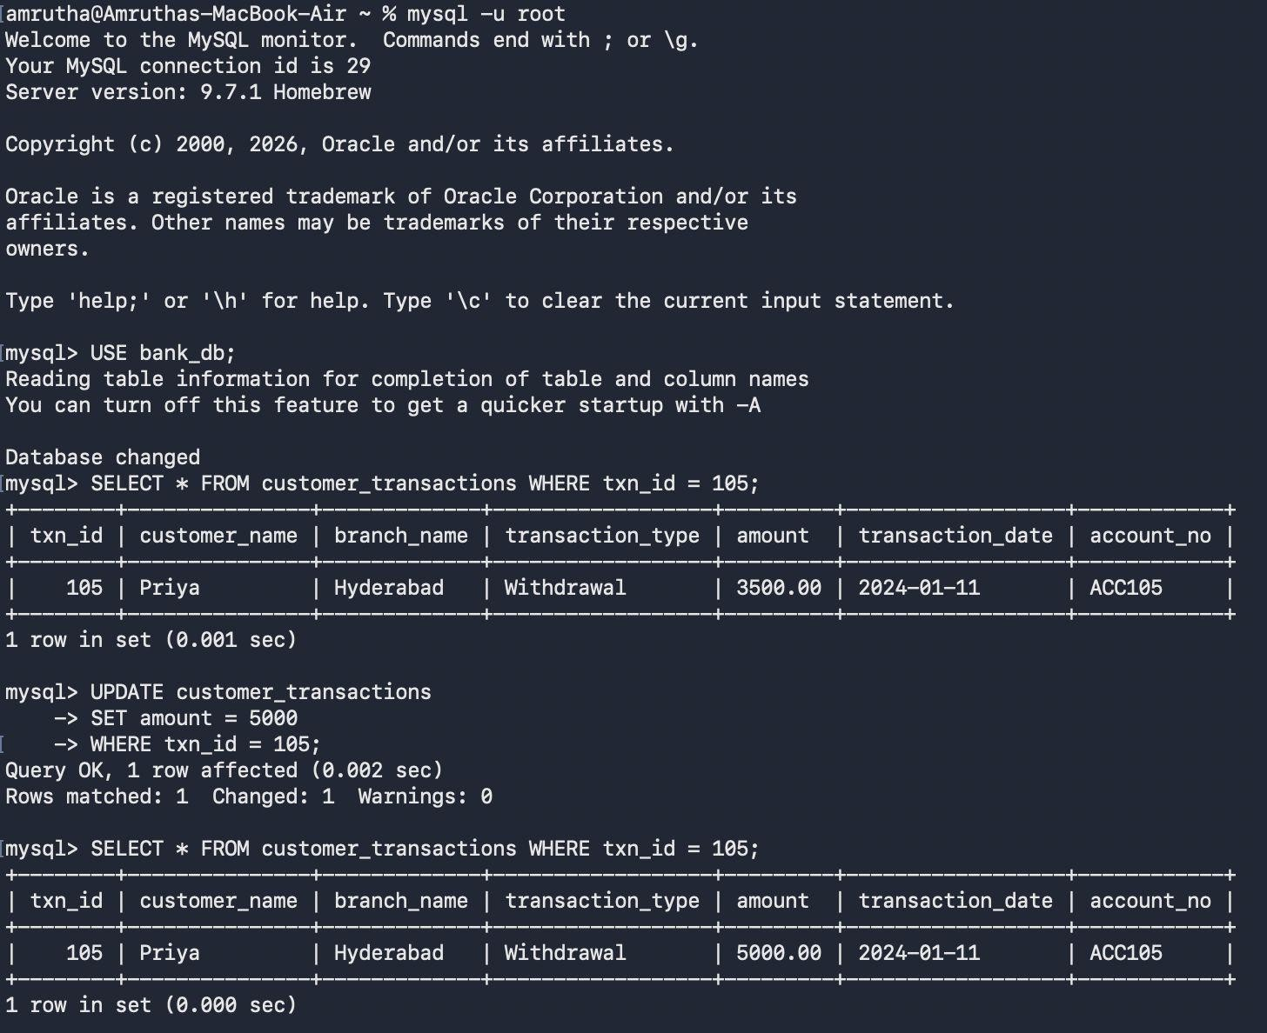

QUESTION 9:- DELETE
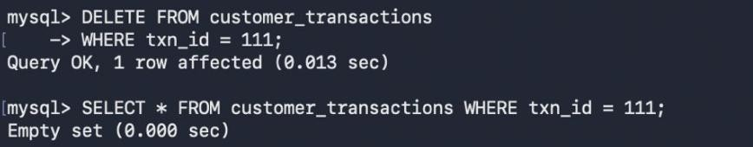

QUESTION 10:- SELECT
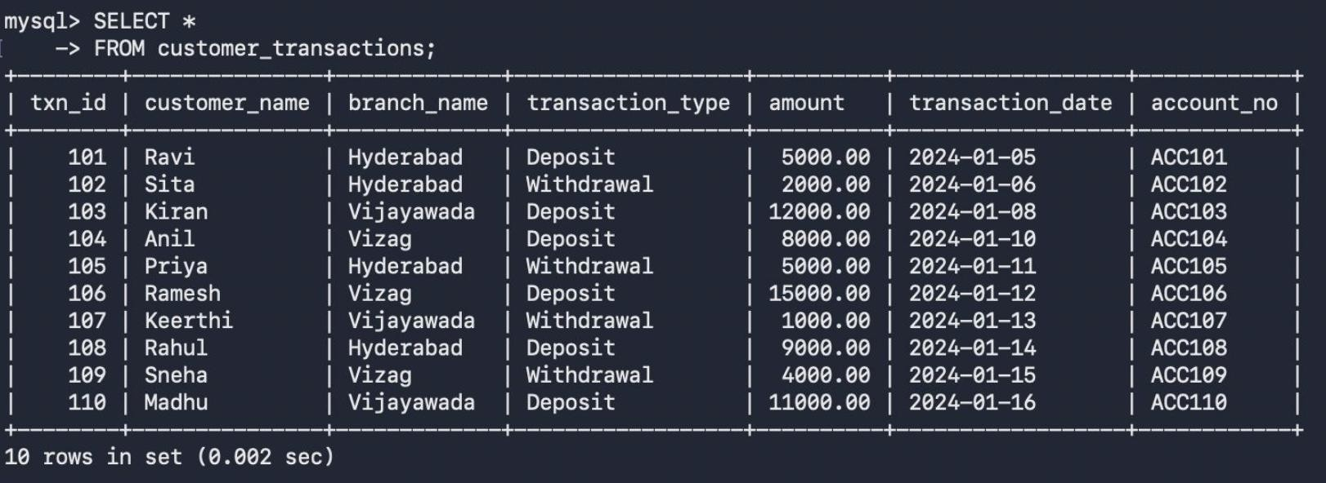

QUESTION 11:- SELECT WITH WHERE
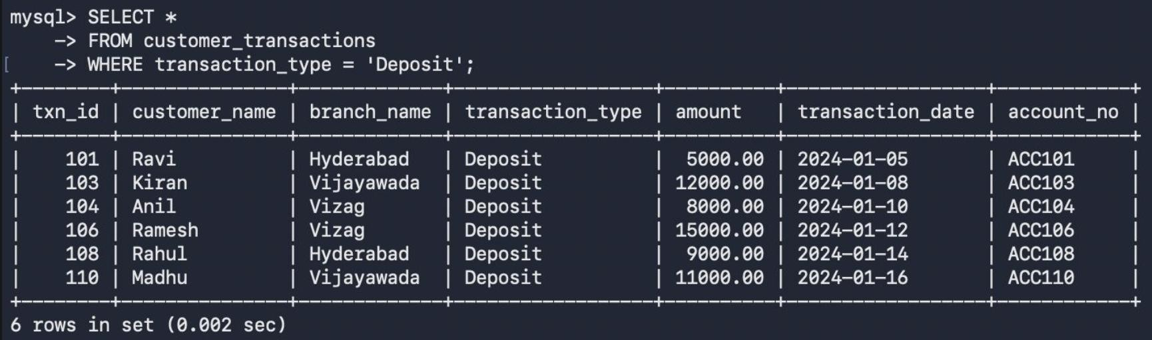

QUESTION 12:- SELECT WITH ORDER BY
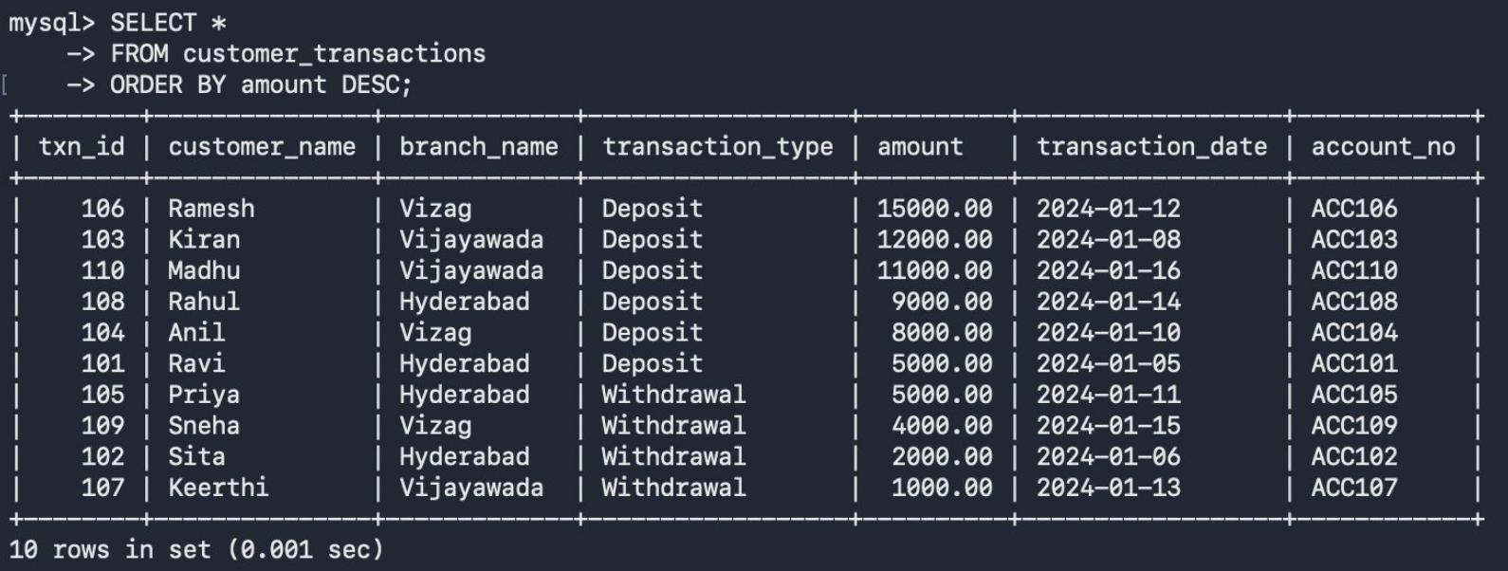

SECTION 3: DCL(DATA CONTORL LANGUAGE)

QUESTION 13:- GRANT SELECT
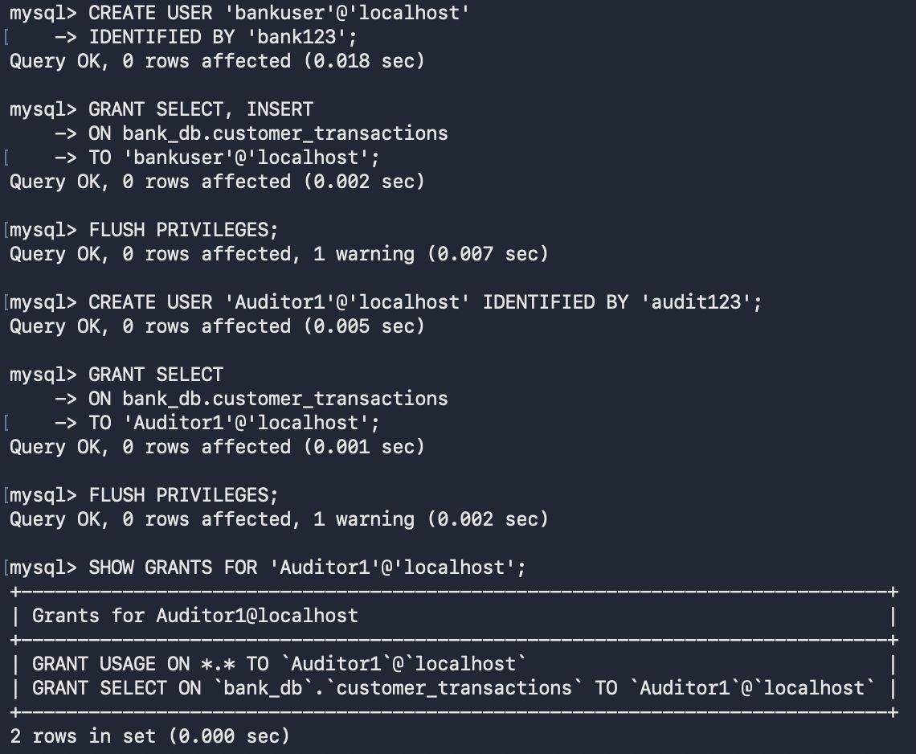

QUESTION 14:- GRANT ALL PRIVILEGES
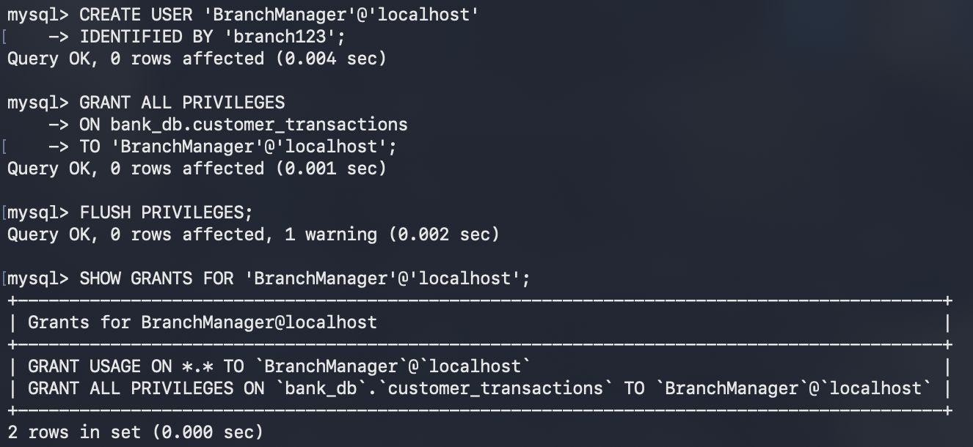

QUESTION 15:- REVOKE SELECT
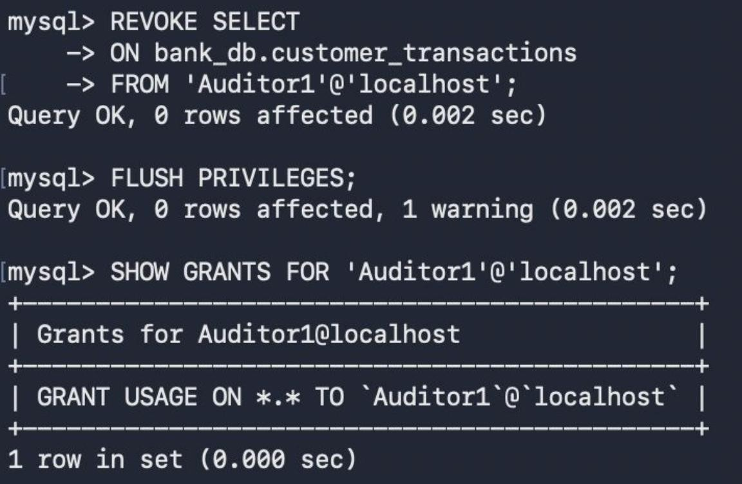

QUESTION 16:- REVOKE ALL
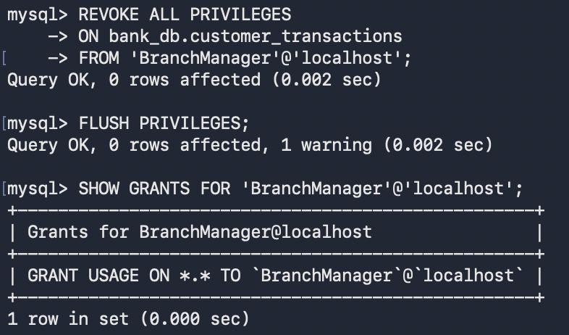

SECTION 4: TCL(TRANSACTION CONTROL LANGUAGE)

QUESTION 17:- COMMIT
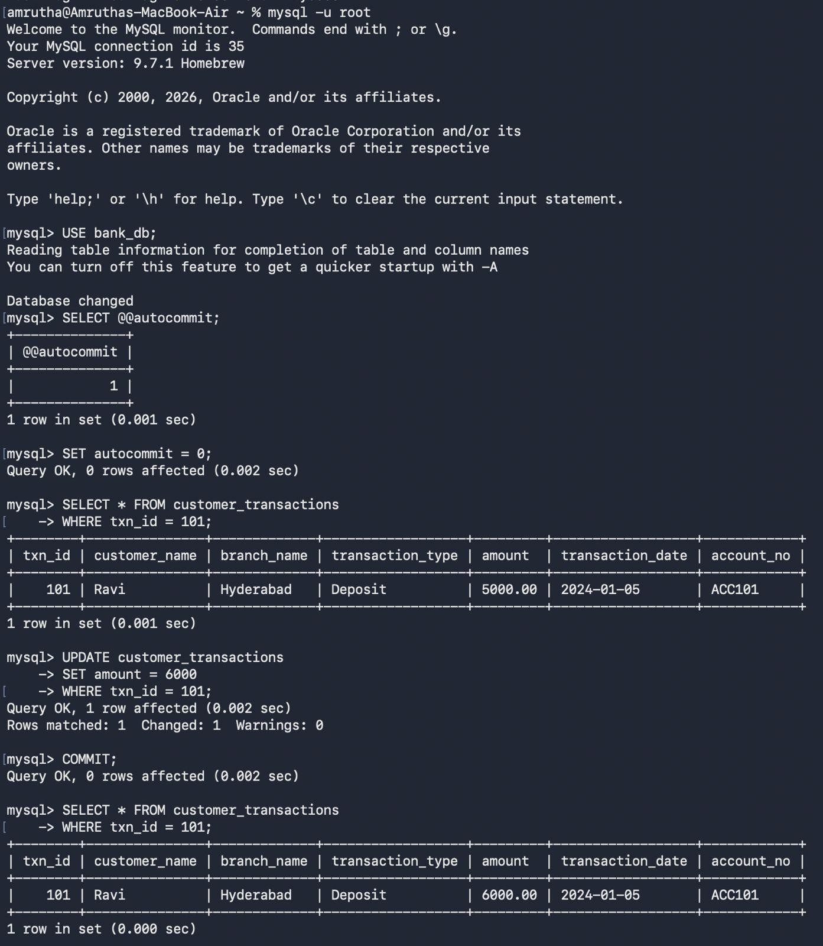

QUESTION 18:- SAVEPOINT
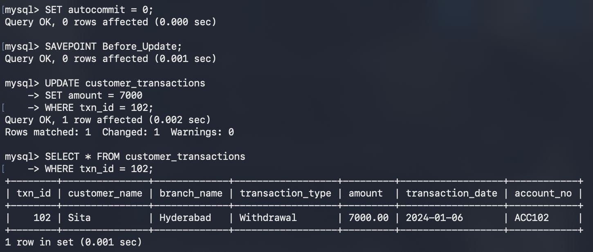

QUESTION 19:- ROLLBACK TO SAVEPOINT
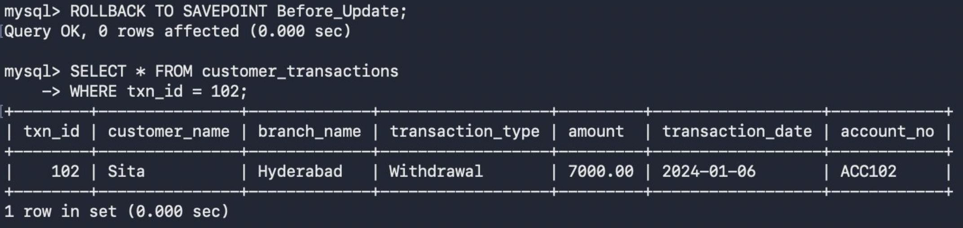

QUESTION 20:- FULL TCL EXAMPLE
